**Space Systems Research**

**At**

**Korea Aerospace University**



**Grant Completion Final Report**

**Matthew Mark D’Arcy**

**August 7, 2015**

**i.) Abbreviated Terms**

|  |
| --- |
| **ADCS –** Attitude Determination and Control Subsystem |
| **ADC-SSS –** Attitude Determination and Control Sensor Simulation System |
| **DAC** – Digital-Analog Converter |
| **KAU –** Korea Aerospace University |
| **KAUSAT-5 –** Korea Aerospace University Satellite 5 |
| **MATLAB –** Matrix Laboratory |
| **SPI –** Serial-Peripheral Interface |
| **SSRL –** Space Systems Research Laboratory |
| **STK –** Systems Toolkit |
| **TWI –** Two-Wire Interface |
| **USART** – Universal Synchronous/Asynchronous Receiver/Transmitter |

**I.) Introduction and Alterations in Scope**

At the time of my application submittal for the 2014-2015 Fulbright US Student Program in South Korea, I had proposed to join the Space Systems Research Laboratory (SSRL) of Korea Aerospace University (KAU) on the Korea Aerospace University Satellite 5 (KAUSAT-5) project. KAUSAT-5 is the name coined for a 3U CubeSat1 in development, a cubic form-factor structural bus stacked three times into a single unit, and its mission objectives are to perform infrared observation of the Earth, measure radiation in the ionosphere, demonstrate a fuzzy-logic controller for solar power generation, and demonstrate successful attitude control through actuation of the custom control moment gyroscope.

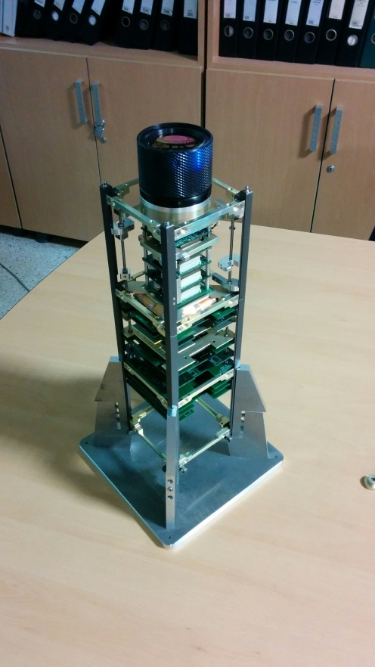 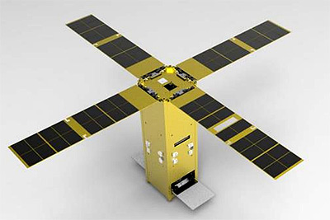

Figure - KAUSAT-5 Structure w/ Camera (L) and Flight Model 3D Render (R)

KAUSAT-5 was to already have been handed off to the launch service and prepped for a November 2014 insertion into orbit. Therefore, I had initially proposed to carry on with the line of work I had been involved in during my 2012 internship at NASA – Marshall Space Flight Center: mission design. I would have become familiar with the ground station and communication protocol specific to KAUSAT-5, and perform the communications necessary to carry out the mission.

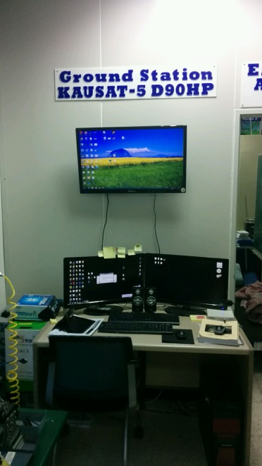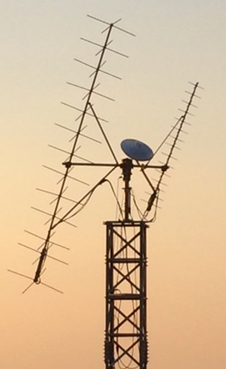

Figure - SSRL Ground Station Console (L) and Antennae (R)

I would have used the data collected from KAUSAT-5’s mission to run performance and feasibility analyses culminating in the design and proposal of a new academia-scale small spacecraft mission involving multiple CubeSats collaborating in a flying formation, or ‘constellation’, to produce a desired effect. The key strength of this scheme is that multiple smaller, lighter, cheaper spacecraft can produce similar if not better mission results than larger, heavier, expensive spacecraft.

However due to delays on the launch provider’s end, cascading into delays from the students’ end, KAUSAT-5’s engineering test model (the first of two constructs, to be followed by the flight model) had not yet begun. The undergraduate and graduate students involved in the project were still at work designing and customizing the mechanical and electrical components specific to their own subsystems. Due to the delays, it was fitting for me to be involved in the development of the project.

The seven subsystems of KAUSAT-5, each covering a different functionality of the spacecraft, include the Attitude Determination and Control Subsystem (ADCS). A spacecraft’s attitude describes its orientation in space relative to other bodies such as the Earth or the Sun. Attitude determination and control describes the processes by which a spacecraft processes data from various sensors to determine how it is oriented in space, and actuating mechanisms to manipulate its attitude, such as reaction wheels, gyroscopes, and thrusters. A spacecraft’s attitude is important to its mission whenever its sensors or instruments require pointing in a specific direction. Two examples include cameras observing the Earth and solar cells absorbing the sun’s rays.

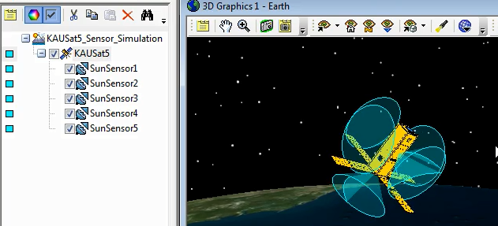

Figure - KAUSAT-5 w. 5x Sun Sensors and Conical FOV

Though the structural and mechanical subsystem would have been more aligned with my mechanical engineering background, the lab supervisor recommended I go outside of my comfort zone and learn new technical skills on a full concept-to-practice project. I was given the opportunity to be the developer of the KAUSAT-5 Attitude Determination and Control Sensor Simulation System (ADC-SSS).

The ADC-SSS is a concept conceived by the lab’s supervisor some years ago during the planning and design of KAUSAT-5. The purpose of the ADC-SSS is to provide simulated sensor data for KAUSAT-5’s ADCS so the developers can verify the attitude control algorithm with the spacecraft still on the ground. While this verification process is typically performed for large, expensive spacecraft, the trend for lighter, faster, cheaper CubeSats has been to simply code the control algorithm and ship for launch or include a passive system such as a gravity-gradient boom; an appendage extending from the CubeSat that utilizes the difference in gravitational pull on the satellite versus the boom’s tip-mass to orient the spacecraft.

**II.) Project Goals**

The main project goal was to create a fully-functioning ADC-SSS ready for integration with the KAUSAT-5 ADCS. The system required the transmission of data of five sun sensors, and three-axis magnetic and gyroscope sensors from PC software to a microcontroller and then on to a third microcontroller. The data transmissions needed to maintain integrity and occur once per second.

Secondary project goals included all of the personal study and skills developed during the course of the project.

**III.) Methodologies and Timeframe**

The ADC-SSS was meant to include several layers of hardware and software to interface with the CubeSat’s ADCS. The configuration can be described by following a packet of data—a group of sensors’ data values at any single moment in time—from creation to delivery to the ADCS.

The entire process starts in a mathematical analysis tool frequently used in engineering applications: Matrix Laboratory (MATLAB). The user is able to code custom programs that enable MATLAB to manipulate other computer software. The Systems Toolkit (STK) software suite allows for visual and statistical analyses of land, air, sea, and spacecraft, and MATLAB was scripted according to the projected launch parameters to create a KAUSAT-5 simulated scenario within STK.

**IV.) Outcome and Results**

A functional MATLAB-STK code, MASTER/SERVANT embedded C programs, and the simulator box were developed and successfully deliver the desired data to the SERVANT each second during the simulation system’s operation. The system was handed off to the ADCS engineers to continue development of KAUSAT-5’s control algorithm.

**V.) Affiliate Support**

The Space Systems Research Laboratory of Korea Aerospace University is directed by Dr. Young-Keun Chang, an expert in satellite technology and an active member of the international space community. During the Fulbright application phase, I exchanged communications with Dr. Chang regarding the current activities in the lab and alternatives to KAUSAT-5 should the project have suffered cancellation. Other projects included software simulations and analyses of satellite constellations and a small satellite conceptual design software tool.

After expressing my interest in the CubeSat project, Dr. Chang granted me a letter of affiliation offering participation, securement of dormitory accommodations, links to student organizations of interest including KAU’s ballooning, paragliding, and gliding clubs, and involvement in KAUSAT-5’s launch campaign.

Dr. Chang also runs the Global Surveillance Research Center and contracts with the Korean military for space-related projects. The result is that generally Dr. Chang can only dedicate Saturday mornings to his lab students, and so throughout the first half of the year I attended Saturday meetings to better acquaint myself with Dr. Chang and some of the material he taught. The lab tradition is to attend lunch meetings during these days to discuss various topics from Korean culture to Dr. Chang’s life in Korea as well as his study in the US.

Throughout the year, I was able to utilize the campus’ dining hall, which served healthy and enjoyable meals at a reduced price, generally 2,000-3,000 KRW. This made a humongous difference in my spending and I was able to live comfortable during the year in Korea.

The Hwajeon-dong community service center is located a fifteen minute walk from campus and the lab supervisor helped me sign up for a membership to the health club in its basement. However, from December onward I was able to sign up to use the health club located in the basement of the dormitory, a three minute walk from the lab.

While researching at KAU, I was not registered with the university, and had no student ID card. The dormitory staff heard my case and permitted me to enter to utilize the health club at cost, cafeteria, and convenience store when requested. Lab colleagues were generous to have me accompany them into the university library and borrow books on their credentials when needed, such as the C programming materials. Access was granted to a spacious window-side desk, wired/WiFi internet, books, software, and electrical components necessary to develop the project. Materials that were not readily available in the lab were purchased and given to me through utilization of the lab’s budget. In the event of design errors and rendering of materials as useless, I purchased updated materials at my own expense. The lab budget also funded my travel to a conference in Jeju, and equipment tests in Daejeon.

The graduate students in the lab each possessed different areas of expertise within the scope of satellite development, and usually had solutions to my problems when inquired. The lab supervisor served as my mentor day to day and checked my progress, offered aid in solving unexpected software and electrical errors, and guided the project phases from tutorial tasks to project completion. As a result of my time in the lab, I have built up a good relationship with the lab supervisor, and as of the submittal of this report we are discussing avenues through which I may return to Korea for my next step.

**VI.) Project Reflection**

Due to the volatile nature of the space industry, which does not exclude space academia, I did not view my research project in Korea as developing a part of KAUSAT-5 but rather as an immersion experience into Korean culture and academia while playing a technical role of the space systems variety.

Upon my arrival at SSRL the supervisor inquired as to which subsystem I would like to be a part of. I had initially intended to approach the project from a systems engineering perspective, knowing limited information about all subsystems and the overall construct as opposed to specializing. However, after some discussion with the supervisor we reached a mutual agreement that both parties would benefit more from my assignment not only to a specific subsystem but within a new technical area involving a complete project that I would pursue alone.

From my perspective, the appropriateness of this path stemmed from past experiences and future prospects. In the past, I had lacked software and electrical experience entirely, and had even been told in interview feedback that it was so. Additionally, this project was the pursuance of a new technology, which the reduction to practice of would be valuable in application processes for future employment, graduate programs, as well as funding opportunities.

I struggled for several weeks simply because I was trying to run Windows 7 and a lot of heavy software packages on a laptop that came with Windows 8. I needed to re-install Windows several times in order to finally get all of the software packages to function correctly. In the future, building a strong desktop PC is necessary in a laboratory setting. I also learned that when programming, it is beneficial to use a Linux-based system like Ubuntu or Mac OS because many computer programming packages simply work after installation, as opposed to issues that take sometimes multiple days to resolve for Windows users. The software at the lab was Windows-based, but this is something to consider for the future.

Once the software was operational, I began studying STK. I went through two manuals of tutorials to familiarize myself with its protocol, language, and specific data extraction.

Upon completion, I went through a complete manual on C Programming. This was the first time I had approached computer programming in a setting other than a basic engineering course, yet the easy-to-digest explanations brought me through even the most complex topic in the C language with some ease: pointers. I completed the example problems as I read, and was ready to begin simple programming tutorials after three weeks.

For the rest of the year, I was working with two Atmel ATMega128a microcontrollers and peripheral components such as digital-analog-converter (DAC) chips. The ATMega128a datasheet guided me through hardware specifics such as characterizing pins and internal registers. The supervisor started a circuit of simple microcontroller actions such as blinking an LED, rotating a motor, controlling the speed of a motor, and using a switch to perform the previous actuations. With the basic C and embedded programming experience, it was time to begin design of the ADC-SSS.

The data required for KAUSAT-5’s ADC-SSS was dependent on the sensors included in the spacecraft. KAUSAT-5’s design features sun, magnetic, and gyroscope sensors. The sun sensors are placed on five of the six surfaces of the spacecraft and work synchronously to determine the spacecraft’s orientation to the sun. The magnetic sensors measure the X, Y, and Z vectors of Earth’s magnetic field and compare them with the X, Y, and Z vectors of the spacecraft. The gyroscope sensors measure the rotation rate of the satellite in the X, Y, and Z axes during a tumbling scenario. After setting up KAUSAT-5 within STK, defining the 3D Model and orbit characteristics, it was possible to manipulate STK to calculate and export data corresponding to KAUSAT-5’s sensors.

I first needed to program MATLAB to autonomously setup the same KAUSAT-5 orbit scenario, define the sensors, and extract the desired sensor data with each push of a button. The difficulty of this portion of the project was rooted in the fact that the resources online for the MATLAB-STK interface were very limited. I had one YouTube lecture and an unreliable command dictionary to work with, from which I reverse-engineered the script.

MATLAB would take the data from the simulation’s sensors and export it through a universal synchronous/asynchronous receiver/transmitter (USART). The USART converted the data to electrical signals that the individual pins of the microcontroller could read and decipher within the chip.

The microcontroller receiving the data initially was the brain of the simulator box. This microcontroller was also termed the “MASTER” because it was responsible for driving the data in the form of electrical signals to the second “SERVANT” microcontroller. Within the MASTER, the data needed to be processed and sent to the SERVANT through data transmission schemes that included serial-peripheral interface (SPI) and two-wire interface (TWI).

SPI utilizes DAC chips to convert digital values, namely numbers, into analog electrical voltages that can be interpreted by a potentiometer. Such a device is expected to be present in the ADCS and so anything beyond the DAC outputs was outside of the scope of the ADC-SSS.

TWI transmits data through two wires by timing electrical signal pulses, comparable to a Morse code of voltages instead of taps. From my experience in developing the ADC-SSS, TWI is a very timing-intensive operation and caused the most errors throughout the year. Throughout several instances I would find the SERVANT receiving gibberish data, or intermittently failing proper data communication with no indicators of repeatability in the rate of failures.

My approach to fixing these errors was to completely transcribe the ATMega128a data sheet’s section on TWI into my own words twice over, analyzing diagrams and developing a timeline describing how the bits of each register were set (or became set) at each phase in the data transfer, and performing step-by-step register analyses on failure scenarios to get a better understanding of the bug in the microsecond-scale operation.

Toward the beginning of my involvement in the lab, it was difficult to gauge the appropriate work-life balance. Other lab members put in six days of work weekly, lived at the lab, and often worked up to twenty hours daily. For the first several months, I deemed it appropriate to attempt to assimilate and so I worked anywhere from 10 to 12 hours per day and six days per week at the lab. While this helped me learn the material and begin development quickly, it established an awkward feeling for getting out of the lab and socializing and networking. Through observation and conversation with lab members, I determined that the long work hours were not so much because they had work to do, but because the lab culture induced both external and internal pressure on the students. I often would find students at their desks sleeping, playing games, or shopping online. All of this, along with project delays, led me to speak up to the supervisor inquiring about the work schedule scheme. I approached the situation diplomatically as my purpose at SSRL was not to change management, but I voiced my opinion on behalf of other lab members about the notions of a healthy work-life balance and work efficiency. By the springtime, lab members who used to live in the lab were able to move into the dormitory and others began exercising at the health club. While having a firm resolve about this situation earlier on would have proved more rewarding for both my and my colleagues’ experiences, it took some time to accurately assess the environment and progress along a reasonable course of action.

**VII.) Bibliography**

CubeSat. “CubeSat.” CubeSat. August 7, 2015. cubesat.org.

**VIII.) Biography**

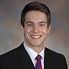

A New Jersey native, Matt grew up between Stratford and Cherry Hill. A large portion of Matt’s childhood was spent at his grandparents’ home where his imagination was free to expand. Matt’s grandfather frequently spoke to him about a career as a Drexel University graduate and electrical engineer during the Apollo missions. Matt became interested in engineering and space exploration through these conversations. While attending Cherry Hill High School West, Matt was particularly intrigued by Instructor Scott Sweeten’s planetary exploration course, which influenced his involvement in the Drexel Space Systems Laboratory.

At Drexel, Matt worked with Korea Aerospace University alumnus Dr. Jin Kang, who was the main influence in Matt’s decision to pursue a Fulbright application to South Korea. In 2014, he graduated with a Bachelor of Science in Mechanical Engineering and Mechanics from Drexel University in Philadelphia. Immediately upon graduation, he joined his fellow Korean Critical Language Scholarship recipients and studied in Wonju, Gangwon-do until commencing research on satellite systems at the Space Systems Research Laboratory of Korea Aerospace University. Matt was the main developer of the attitude determination and control sensor simulation system for a 3U CubeSat – KAUSAT-5. When Matt is not debugging errors, he is involved in outdoor activities, fitness, mobile and web development, networking, travel and rewards profiles, and other space topics.